Title Page
Topic: Business Analytics Project Overview Report: Insider Fraud And Anomaly Detection in Retail Banking Transactions

By: Okoh Chigozie Christiana
Course: BAN6800
Date: September 4th, 2026.

1. Define the Business Problem
Core issue: Mid-sized Nigerian retail banks detect insider and social-engineering-driven fraud primarily through manual reconciliation and static rule-based flagging, rather than continuous, model-driven anomaly detection, this leaves them relying on methods that do not target the fraud technique NIBSS (2026) identifies as most prevalent in the sector.
Applying the define → gather data → analyze → root cause → objectives framework: The problem was defined in the Module 1 Vision Document (Okoh, 2026a) as a detection capability gap. Data gathering draws on the Credit Card Fraud Detection dataset (284,807 real transactions; Kaggle, 2018) for modeling, and on published NIBSS/CBN industry statistics for organizational context.
Analysis and root cause identification are conducted in Section 2 below. The resulting objectives, precision, recall, and triage-time targets carry forward unchanged from the measurable goals set in Module 1, since this plan operationalizes that vision rather than replacing it.

2. Root Cause Analysis

5 Whys
- Why does insider fraud go undetected for extended periods?
Detection relies on manual reconciliation and static rule-based flagging, not continuous behavioural monitoring.
- Why does detection rely on manual reconciliation?
Transaction monitoring systems at most mid-sized banks were built to meet regulatory reporting thresholds, not to detect behavioural anomalies.
- Why were systems built only to reporting thresholds?
Historical CBN/NIBSS requirements were themselves cases and threshold-driven rather than proactive-analytics-driven, so institutions built to the compliance minimum.
- Why did institutions under-invest in analytics beyond that minimum?
The cost of under-investment was not clearly quantified industry-wide until recently.
- Why wasn't that cost quantified earlier? Loss data broken out by specific fraud technique (insider abuse vs. other vectors) was not centrally aggregated and published until NIBSS's 2025/2026 disclosures (NIBSS, 2026), so individual institutions lacked an industry benchmark to justify the investment case internally.
Root cause: the absence of behavioural/statistical anomaly detection capability, historically justified by a lack of industry-wide data isolating insider-fraud losses specifically. That data gap has now closed, which is what makes this project's business case timely rather than speculative.

Fishbone Summary
Category | Contributing Factor
People | Detection currently depends on an individual employee noticing a discrepancy during routine work, not a systematic process.
Process | Reconciliation is periodic (monthly/quarterly), not continuous, creating a detection lag.
Technology | Existing systems are rule-based and threshold-triggered, not model-driven or adaptive.
Data / Regulatory | Industry-wide loss data by fraud technique was not published until 2025/2026, delaying the investment case.
These findings link directly to the KPIs set in Module 1: precision and recall targets address the Technology gap, and the triage-time KPI directly addresses the Process gap (reconciliation lag) identified above.

3. Business Analytics Project Overview
Objectives and scope carry forward from Module 1: Build a predictive fraud-probability classifier and a prescriptive investigation-priority queue, evaluated on the ULB Credit Card Fraud dataset, with deliverables limited to a trained model, an explainability layer, a fairness audit, and an analyst-facing dashboard mockup, not a live production deployment. Data types and sources are detailed in the accompanying Data Dictionary (see submission files): the modeling dataset itself, plus a documented schema for the production data types (core banking feed, KYC metadata, device metadata) a real deployment would require.
The predictive layer is a gradient-boosted classifier (XGBoost) producing a calibrated fraud-probability score (0–1) per transaction, using engineered features from transaction amount, timing, and the anonymized behavioral components V1–28 (Dal Pozzolo et al., 2015). The prescriptive layer does not simply sort by that score: it weights each flagged transaction by estimated loss exposure (probability × transaction amount × account risk tier), so a smaller transaction at a slightly lower probability is not mistakenly deprioritized behind a trivial high-probability case. Each flagged transaction reaches the analyst dashboard with three elements together, not the score in isolation: the priority rank, a SHAP-generated explanation of which features drove the score, and the account's recent transaction history for context. This is the decision-support function this project commits to: narrowing a large transaction volume down to a ranked, explained shortlist an analyst can act on directly, not a raw probability list requiring separate interpretation.

Requirements, By Role
Role | Requirement
Fraud Analyst | Dashboard load time under 5 seconds per flagged case; SHAP explanation rendered inline, not as a separate lookup step.
Compliance Officer | Monthly aggregate report auto-generated in NIBSS-aligned reporting fields, avoiding manual reformatting of model output.
Data Engineer | Automatic retraining trigger when MLflow-tracked recall drops below a defined drift threshold, not only on a fixed schedule.

Non-functional requirements are stated as concrete thresholds rather than general goals: transaction scoring latency under 500ms (this sits in a near-real-time monitoring path, not a batch job); system uptime of at least 99.5%, matching typical core banking SLA expectations; encryption at AES-256 at rest and TLS 1.2+ in transit; and a model performance floor of precision ≥ 85% and recall ≥ 75% on held-out fraud cases before the Ethics Committee (Section 3, Module 1) approves production deployment, giving that review a concrete gate rather than a subjective judgment call.

Technical Architecture
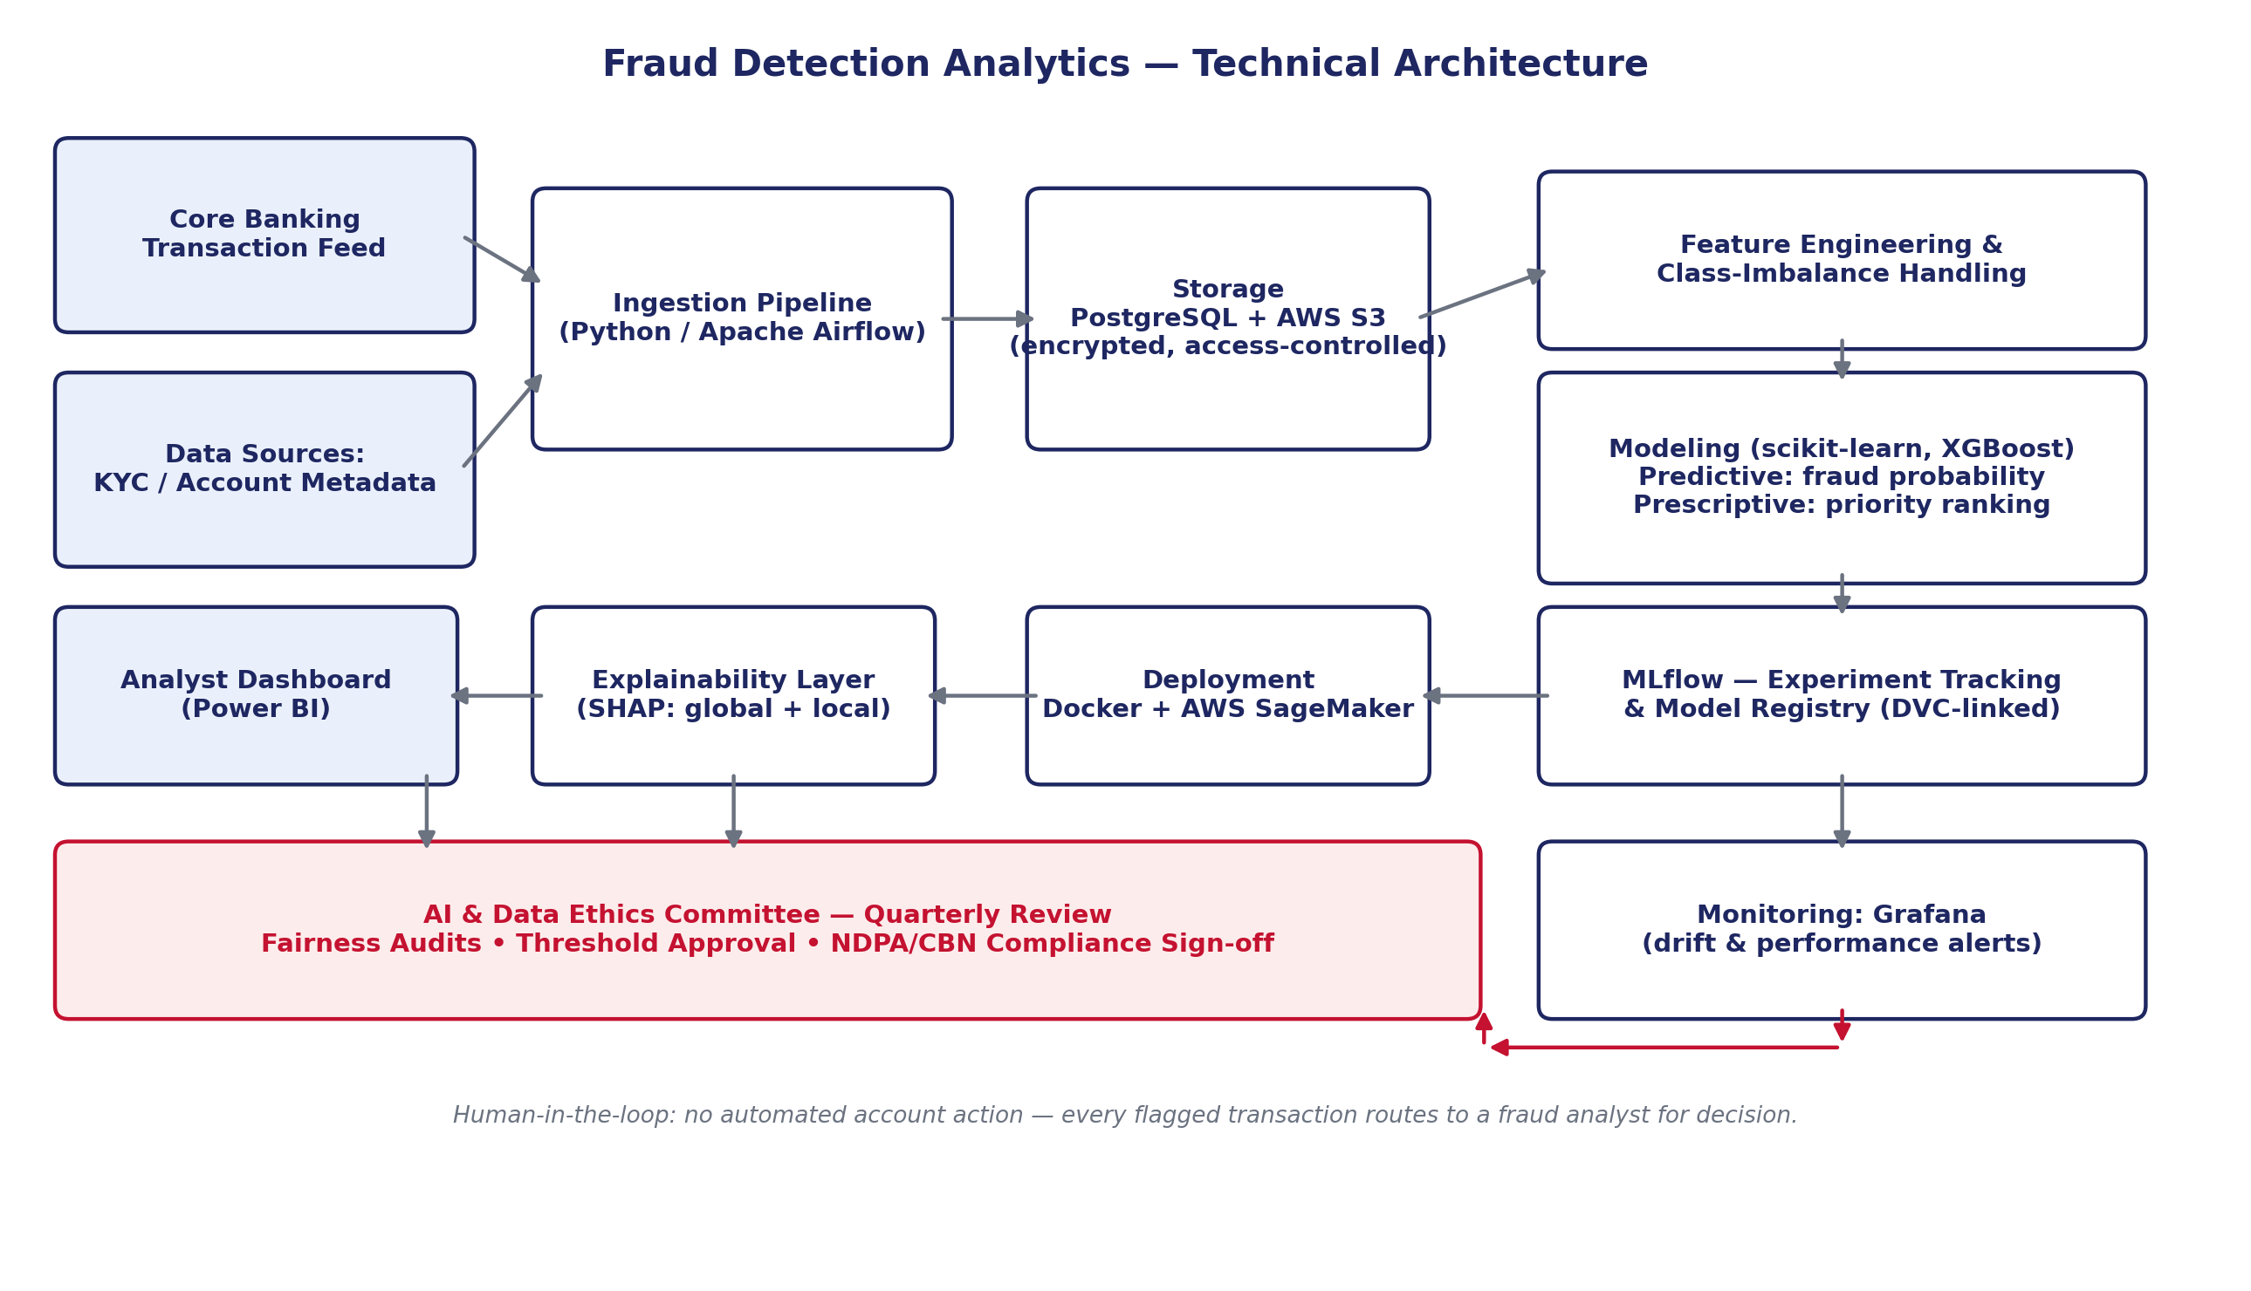
This architecture directly extends the technical stack and repository structure proposed in Module 1 (Okoh, 2026a): the same Python/Airflow ingestion layer, PostgreSQL/S3 storage, MLflow tracking, Docker/SageMaker deployment, and Power BI dashboard, with an explicit SHAP explainability layer and Ethics Committee checkpoint added to operationalize the Ethical AI Vision established in that document.

4. Apply Agile Methodology
This project runs as three two-week sprints, using iterative delivery, continuous feedback, and adaptation rather than a single upfront build. Each sprint ends with a working increment (a data pipeline, then a trained model, then an audited/explainable model), allowing scope to adjust based on what the prior sprint's results show, consistent with agile principles rather than a fixed waterfall plan.
Sprint | Ticket | Deliverable
Sprint 1 (Weeks 1–2) | Set up repo per Module 1 structure; load & profile dataset; write data validation tests | Working ingestion pipeline + data dictionary
Sprint 1 | Handle class imbalance (SMOTE/class weighting); baseline logistic regression model | Baseline model + evaluation report
Sprint 2 (Weeks 3–4) | Train XGBoost classifier; log experiments in MLflow | Trained predictive model
Sprint 2 | Build prescriptive priority-ranking logic on top of model scores | Prescriptive queue prototype
Sprint 3 (Weeks 5–6) | Integrate SHAP explainability layer; run Fairlearn fairness audit | Explainability report + fairness audit results
Sprint 3 | Build Power BI dashboard mock-up; Ethics Committee review checkpoint | Dashboard mock-up + governance sign-off

Shown and detailed my Github.

5. Implementation and Communication Plan
Stakeholder | Role | Communication Cadence
Chief Risk Officer | Accountable for loss exposure; final sign-off on deployment | End-of-sprint demo (3x)
Head of Compliance | NDPA/NIBSS reporting alignment | Sprint 3 governance review
Fraud Analysts (users) | Dashboard usability feedback | Sprint 2–3 usability sessions
AI & Data Ethics Committee | Fairness audit review, threshold approval | Sprint 3 checkpoint (Section 6)
Success is measured against the KPIs set in Module 1: flagged-transaction precision, fraud recall on held-out cases, and average investigator triage time, tracked sprint over sprint rather than only at project close, so a KPI trending in the wrong direction triggers a scope conversation before the final sprint, not after it.
A condensed view of the project's top risks, assumptions, issues, and dependencies is below; the full Technical RAID Log is included as a separate spreadsheet in my submission.
Type | Item | Mitigation
Risk | 0.172% fraud rate biases the model toward predicting ‘not fraud’ | Class weighting/resampling; evaluate on PR-AUC and recall, not accuracy
Assumption | Historical data adequately represents both normal and fraudulent patterns | Validate via EDA in Module 3; flag underrepresented segments
Dependency | Module 3 modelling work depends on this architecture and repo being finalized first | Freeze repo structure and environment file before Module 3 begins

6. Privacy, Fairness, and Compliance Requirements

Data Privacy Plan
Modelling features (V1–28) are already PCA-anonymized at source (Kaggle, 2018); any production extension using real KYC/device data would require role-based access control, encryption at rest and in transit, and a documented retention schedule, consistent with NDPA 2023 Section 24 safeguarding requirements and its 72-hour breach notification rule (Dimeri, 2026).

Fairness Metrics
This project adopts Demographic Parity and Equalized Odds, the two-fairness metrics most established in financial fraud/AML literature (Databricks, 2022; Springer Discover AI, 2026), evaluated via the Fairlearn library. Equalized Odds is prioritized as the primary metric, since it evaluates true- and false-positive rate parity across groups rather than raw flagging rate, which better fits a context where the underlying fraud rate may legitimately differ across segments (SHAP documentation, n.d.).

Explainability Framework
SHAP (SHapley Additive exPlanations) is adopted as the explainability method, providing both global explanations (which features drive fraud predictions overall) and local, per-transaction explanations for analyst review, consistent with recent applications of SHAP specifically to credit card fraud models (Researchgate, 2026).

Regulatory Compliance Checklist
Requirement | Status / Action
NDPC registration (if “major importance” controller) | To confirm at production-scale deployment; not applicable to this academic modelling exercise
Data Protection Impact Assessment (DPIA) | Required before production use; documented as a Sprint 3+ follow-on item
Lawful basis for processing (NDPA S.25 / GDPR-equivalent) | Public dataset used under its stated research/education license (Kaggle, 2018)
Breach notification (72 hours, NDPA) | Documented as a production operating procedure, not applicable to static dataset use
CBN/NIBSS monthly fraud reporting (BOFIA 2020 S.24) | Referenced as the downstream reporting requirement this project's output would feed

References
- Dal Pozzolo, A., Caelen, O., Johnson, R. A., & Bontempi, G. (2015). Calibrating probability with undersampling for unbalanced classification. 2015 IEEE Symposium Series on Computational Intelligence. https://doi.org/10.1109/SSCI.2015.33.
- Databricks. (2022). Mitigating bias in ML with SHAP, Fairlearn. https://www.databricks.com/blog/mitigating-bias-machine-learning-shap-and-fairlearn.
- Dimeri. (2026). Nigeria Data Protection Act (NDPA) 2023: Complete compliance checklist. https://www.dimeri.ai/blog/guides/ndpa-compliance-checklist-nigeria.
- Kaggle / Machine Learning Group, Université Libre de Bruxelles. (2018). Credit card fraud detection [Data set]. https://www.kaggle.com/datasets/mlg-ulb/creditcardfraud.
- Nigeria Inter-Bank Settlement System (NIBSS). (2026). Digital payment fraud drops 51% to N25.85b, Lagos accounts for 63%. https://nibss-plc.com.ng/digital-payment-fraud-drops-51-to-n25-85b-lagos-accounts-for-63/.
- Okoh, C. (2026a). Business analytics project vision document: Insider fraud & anomaly detection in retail banking transactions [Module 1 assignment]. Nexford University.
- ResearchGate. (2026). Explainable AI (XAI) analysis using SHAP for credit card fraud. https://www.researchgate.net/publication/400212662.
- SHAP Documentation. (n.d.). Explaining quantitative measures of fairness. https://shap.readthedocs.io/en/latest/example_notebooks/overviews/Explaining%20quantitative%20measures%20of%20fairness.html.
- Springer Discover Artificial Intelligence. (2026). Explainable and fair anti-money laundering models using a reproducible SHAP framework for financial institutions. https://link.springer.com/article/10.1007/s44163-026-00944-7

